# CS 255 System Design Document

## UML Diagrams

### UML Use Case Diagram

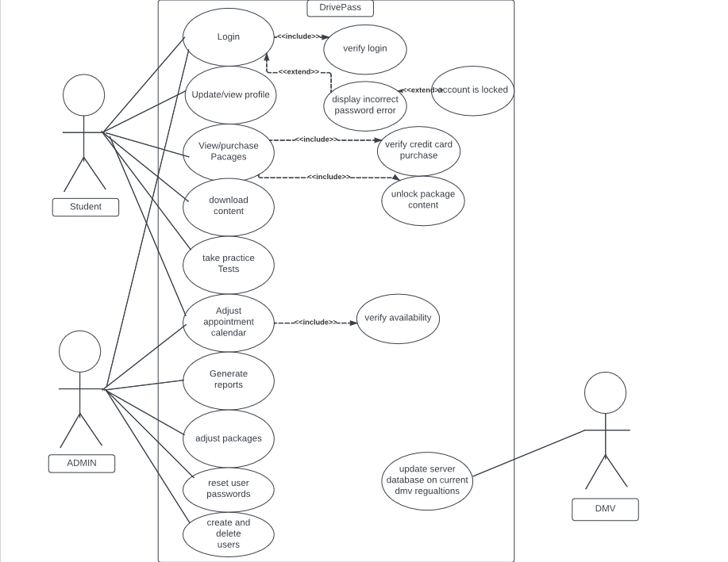

### UML Activity Diagrams

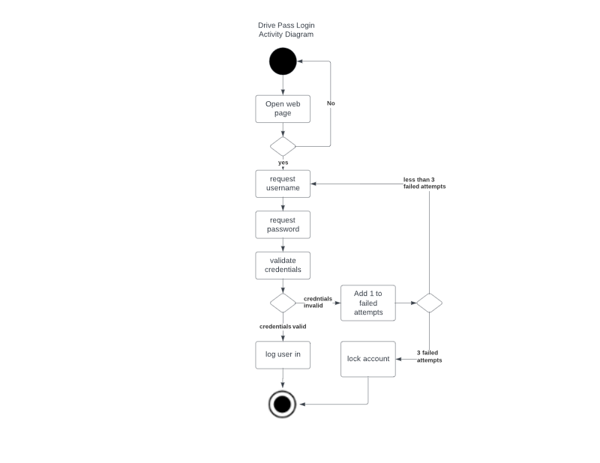

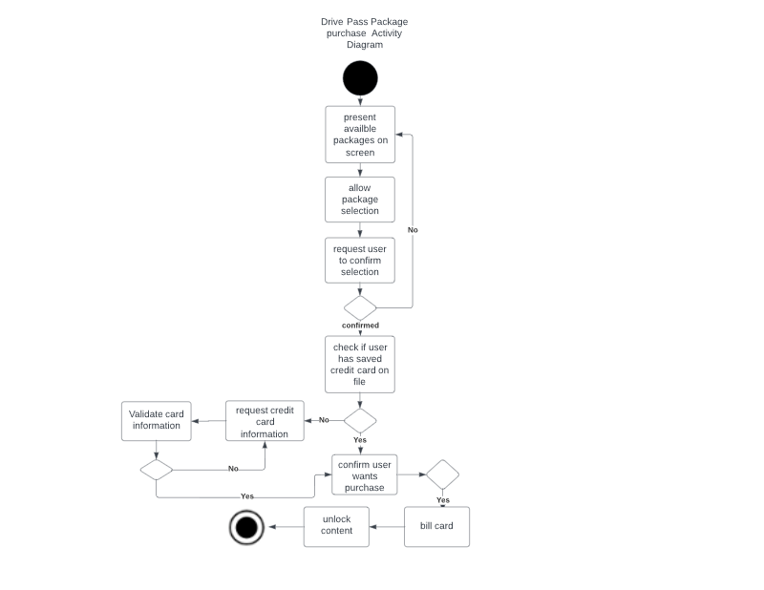

### UML Sequence Diagram

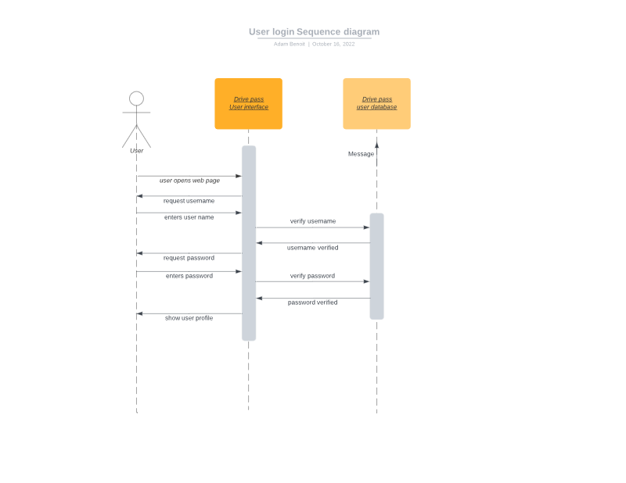

### UML Class Diagram

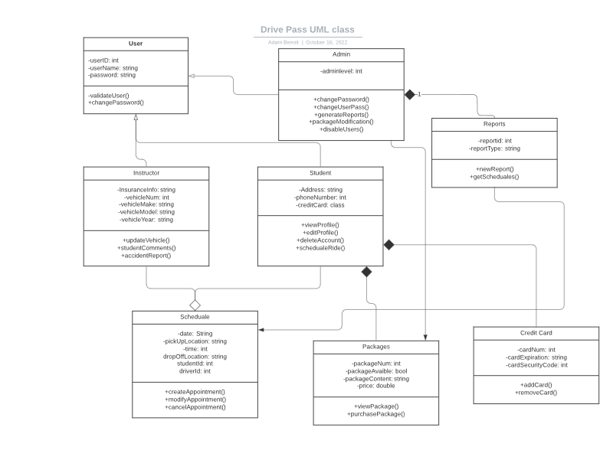

## Technical Requirements

* Host machine to run web interface and host the database
* Payment processing software
* Stable internet and a back up internet incase the first service is down
* Cabling for internet
* Stable power source
* Encryption and antivirus to protect the server
* Firewalls to filter internet traffic